Shammah Thao

EEE 174 - CpE 185 Lab Section #2

Monday & Wednesday

Lab 6 – Area of Interests

Dahlquist

Introduction:

For this lab, I decided to do a HTML website. This was a static website, which basically mean that there would not be any changed to the website by interacting with it. You will need to go into the coding to be able to make changes. My static website was made to display different kind of thing you could do. The reason I chosen this project was because I was interested in the way that website is made, pulling up page inspect shows complex coding of html which is not as beneficial to me as starting from the basic.

Demo:

For my coding, I made with a basic html format. The structure was do I would be able to do thing step by step, so if I were to mess up with the coding, I would be able to easily find my mistake and fix it.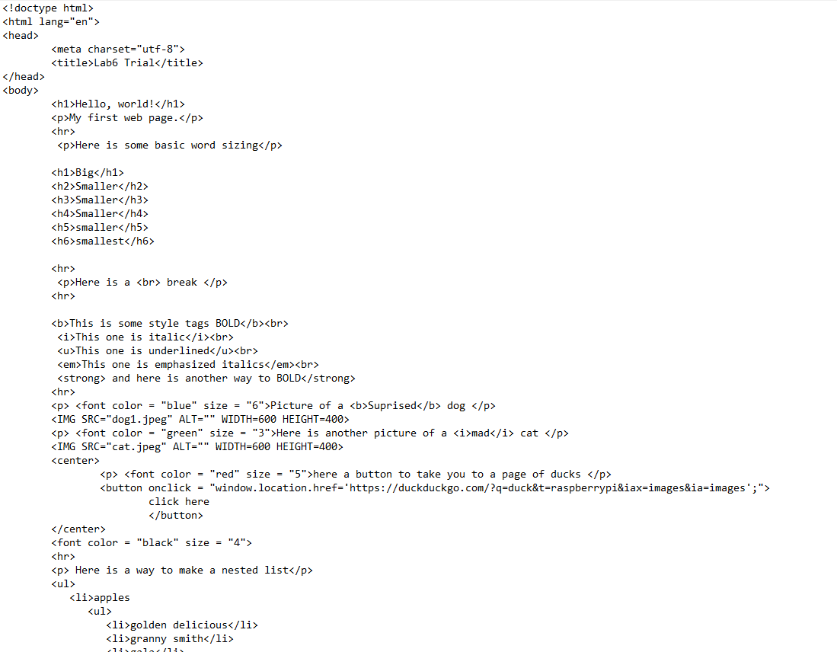

The result, show below, feature making the words bigger or smaller, making a break in a sentence, different style tags, also adding picture and redirect links. There are different ways that the words can be presented to users. There are also ways that you can decorate wordings to make them more colorful

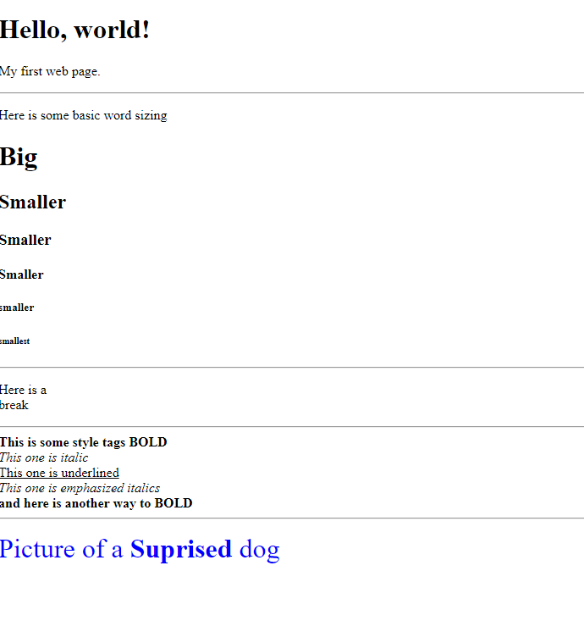

Conclusion:

In conclusion, do this lab was beneficial for just me learning how coding html static website works. It is a basic way of learning from the beginning then heading into dynamic websites. Being able to be told to go do what you think you will find interesting is a great way to expand people knowledges.